Supplementary Instructions

For additional questions or concerns please email INFO@MODULARORGANICS.COM
or call 360.674.2642

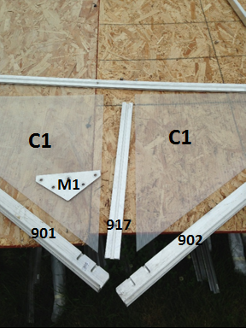

Gather all parts necessary for assembling the top of the gable.

Make sure to insert Polycarbonate pieces into Aluminum profiles before inserting bolts into channels

Once bolts are inserted slightly tighten nuts, at the top, working downward to position and bolt the rest of the gable.

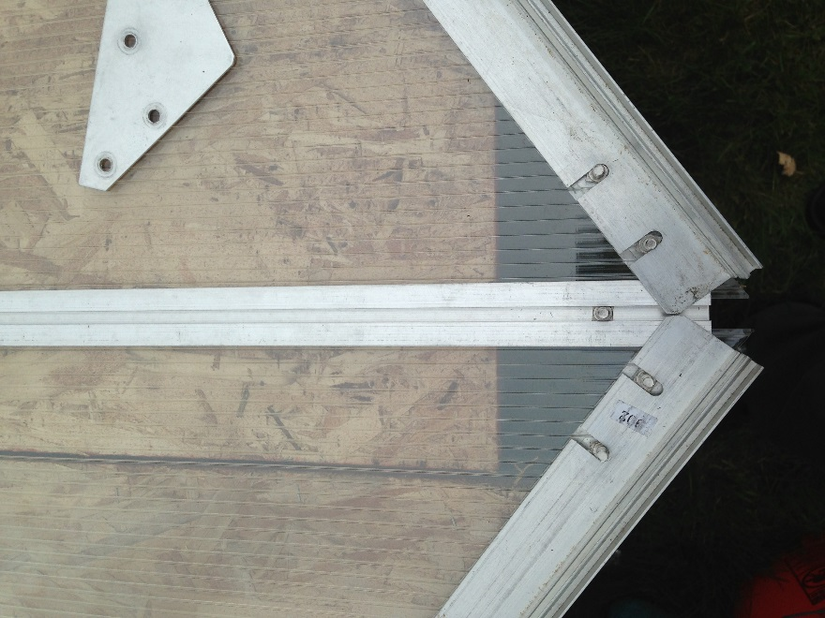

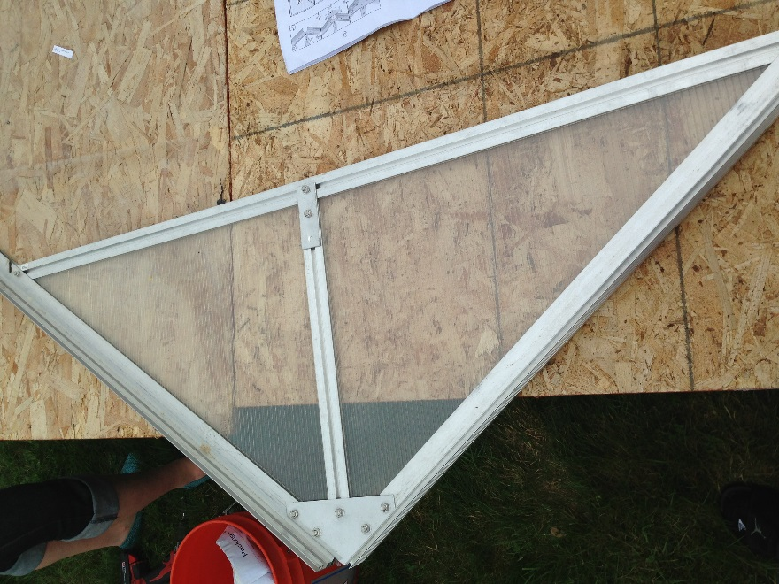

The completed top of the gable should look like the image on the right.

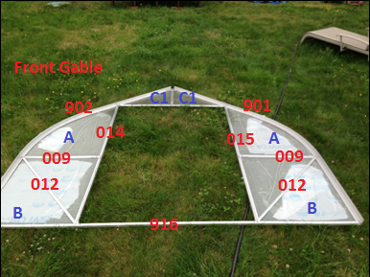

For the Rear Gable it is recommended to first assemble the ridge plate and supporting aluminum parts #; 908, 911, 907, 005, and 006 BEFORE inserting polycarbonate panels. This will keep the panels from shifting. Then once the panels are inserted, start from one side and loosen the bolts connecting #911 in order to insert part #009. Retighten bolts after pieces are in place and repeat this process all the way across.

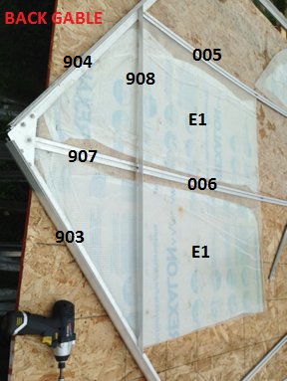

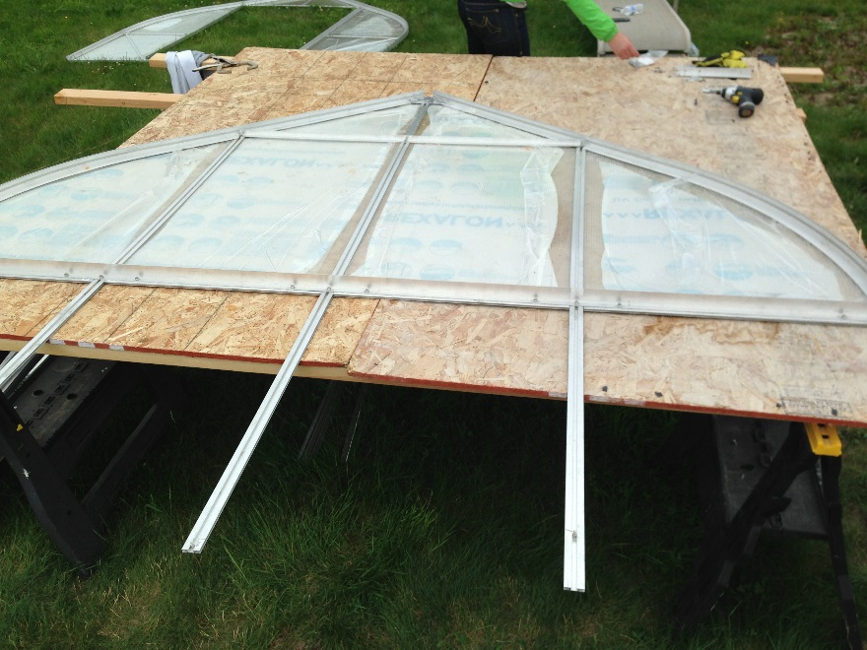

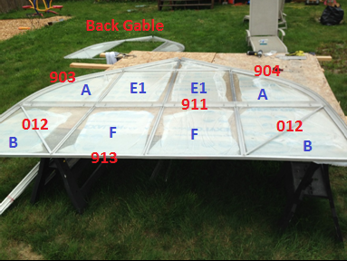

Once both gables are completed, insert them into the aluminum base and connect using the ridgepole

